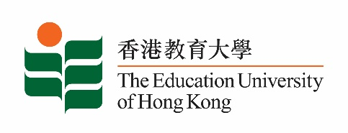

5 September 2025

**致：**  **傳媒機構採訪主任**

**To : News Editors**

**香港教育大學（教大）2025年9月8日至21日可供採訪之活動一覽**

**The Education University of Hong Kong (EdUHK) Events Calendar for 8-21 September 2025**

本校誠邀　貴機構派員採訪下列活動。傳媒查詢，請聯絡教大傳訊處（電話：2948 6050）。  
You are cordially invited to cover the events below. For media enquiries, please contact the Communications Office at 2948 6050.

以下活動或有人數限制，傳媒請預先向主辦部門登記。

There may be restrictions on the number of participants for the following event(s). Please contact the respective organiser(s) / department(s) for prior registration.

* **教大大埔校園**（新界大埔露屏路十號）

**EdUHK Tai Po Campus** (10 Lo Ping Road, Tai Po, New Territories)

|  |  |  |  |  |  |
| --- | --- | --- | --- | --- | --- |
| **日期**  **Date** | **時間**  **Time** | **活動**  **Event** | **地點**  **Venue** | **主辦部門及公眾查詢**  **Organiser &**  **Public Enquiry** | **備註**  **Remarks** |
| 2025-09-13 to 2025-09-14 | 0900-1800 | 一帶一路藝術與文化國際研討會  International Conference on One Belt One Road Arts and Culture 2025 | 香港故宮文化博物館  Hong Kong Palace Museum | 文化與創意藝術學系  Department of Cultural and Creative Arts  查詢/ Enquiries:  梁博士/ Dr Leung  icoac25@eduhk.hk  電話/ Tel: 2948 7168 |  |